**Lab 4: Android RelativeLayout**

# **Introduction**

Relative Layout Specify the positions of views relative to other views.

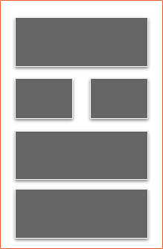

**Relative Layout Attributes**

|  |  |
| --- | --- |
| **Attribute** | **Description** |
| id | Used to uniquely specify |
| gravity | Used to specify child position |
| ignoreGravity | Used to specify which need to be ignored for gravity |

# **Let’s get Started**

You'll be guided through easy stages in this exercise to design your own Android application utilising Relative Layout.

**Step 1: Create a New Project in Android Studio as shown below**

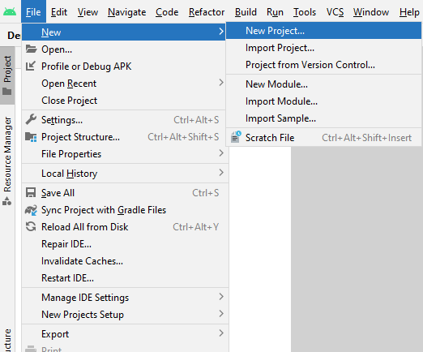

**Step 2: Select Empty Activity as shown below**

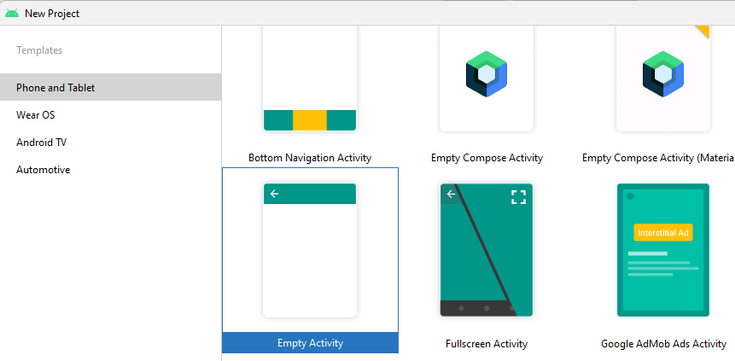

**Step 3: Provide a Project Name as shown below**

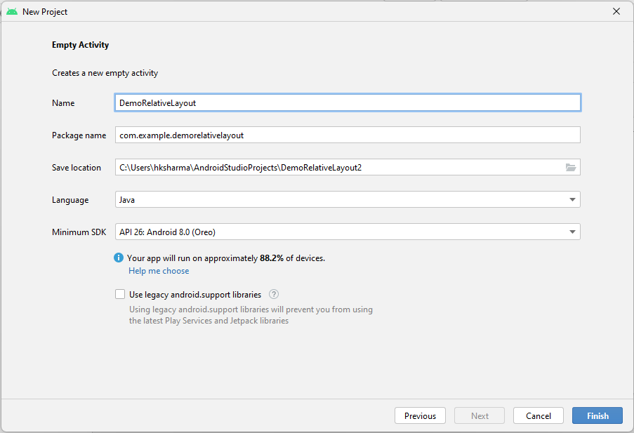

**Step 4: Update MainActivity.java as per the code given below**

**package** com.example.demorelativelayout;  
**import** androidx.appcompat.app.AppCompatActivity;  
**import** android.os.Bundle;  
**public class** MainActivity **extends** AppCompatActivity {  
 @Override  
 **protected void** onCreate(Bundle savedInstanceState) {  
 **super**.onCreate(savedInstanceState);  
 setContentView(R.layout.***activity_main***);  
 }  
}

**Step 5: Update activity_main.xml for Relative Layout as per the code given below**

*<?***xml version="1.0" encoding="utf-8"***?>*<**RelativeLayout xmlns:android="http://schemas.android.com/apk/res/android"  
 android:layout_width="fill_parent"  
 android:layout_height="fill_parent"  
 android:paddingLeft="16dp"  
 android:paddingRight="16dp"** >  
  
 <**EditText  
 android:id="@+id/name"  
 android:layout_width="fill_parent"  
 android:layout_height="wrap_content"  
 android:hint="@string/name"** />

<**LinearLayout  
 android:orientation="vertical"  
 android:layout_width="fill_parent"  
 android:layout_height="fill_parent"  
 android:layout_alignParentStart="true"  
 android:layout_below="@+id/name"**>  
  
 <**Button  
 android:layout_width="wrap_content"  
 android:layout_height="wrap_content"  
 android:text="Button 1"  
 android:id="@+id/button"** />  
  
 <**Button  
 android:layout_width="wrap_content"  
 android:layout_height="wrap_content"  
 android:text="Button 2"  
 android:id="@+id/button2"** />

<**Button  
 android:layout_width="wrap_content"  
 android:layout_height="wrap_content"  
 android:text="Button 3"  
 android:id="@+id/button3"** />

<**Button  
 android:layout_width="wrap_content"  
 android:layout_height="wrap_content"  
 android:text="Button 4"  
 android:id="@+id/button4"** />  
  
 </**LinearLayout**>  
  
</**RelativeLayout**>

**Step 6: Check Output on Android Emulator and it should look like as given below**

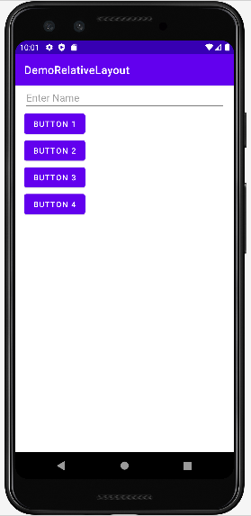

**Voila!!** We have successfully completed this lab.